**Yara jamal mahmoud**

**Lab2**

**Bash script**

1. #!/bin/bash

read -p "please enter your name :" username

echo "welcome $username"

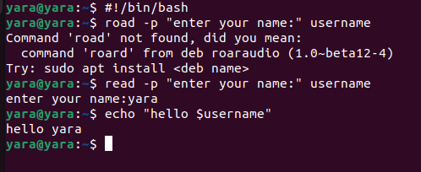

2-

Create vi s1.sh | vi s2.sh

S1

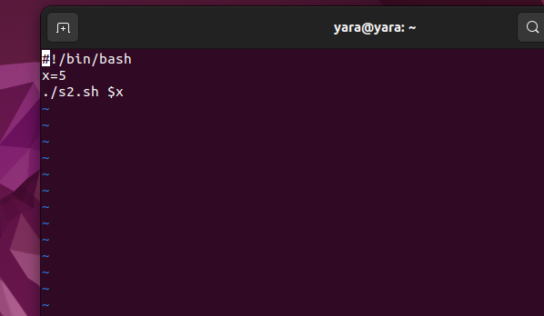

S2

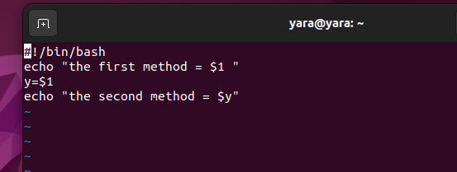

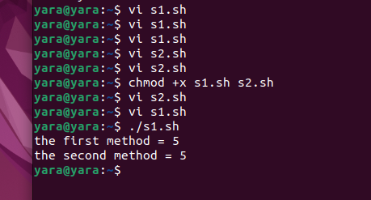

**3-**

Create vi mycp.sh

**#!/bin/bash**

**if [ $# -eq 2 ]; then**

**cp "$1" "$2"**

**echo "The file $1 is copied to $2"**

**fi**

**if [ $# -gt 2 ]; then**

**directory="${!#}"**

**cp "${@:1:$#-1}" "$directory/"**

**echo "Files copied to directory $directory"**

**fi**

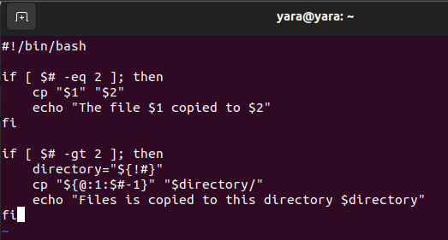

**Touch first second third**

**Mkdir yaradir**

**Chmod +x mycp.ch**

**./mycp.sh first second**

**./mycp.sh first second third yaradir**

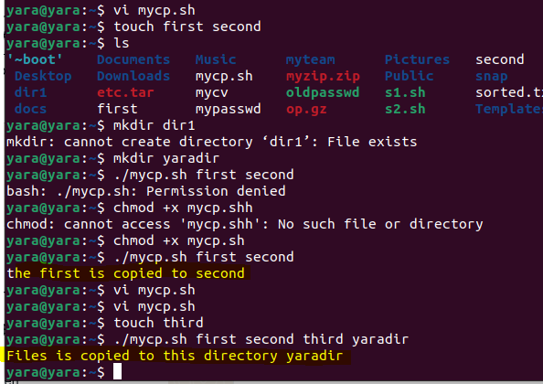

**4-**

**Vi cd.sh**

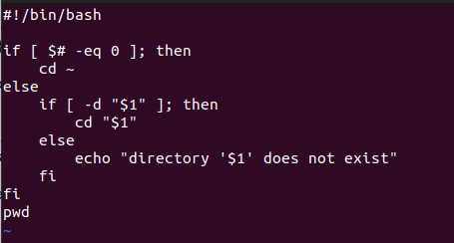

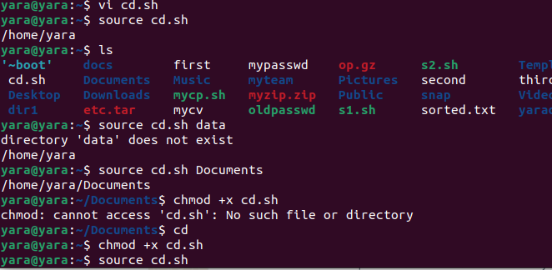

**5-**

**Vi myls.sh**

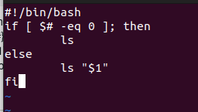

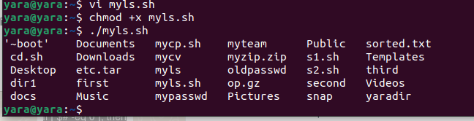

**6-**

**#!/bin/bash**

**read -p "Please enter command: " command**

**case $command in**

**"ls -l")**

**echo "Display in long format."**

**;;**

**"ls -a")**

**echo "Display all entries including hidden files."**

**;;**

**"ls -d")**

**echo "List directories themselves, not their contents."**

**;;**

**"ls -i")**

**echo "Print the inode number of each file."**

**;;**

**"ls -R")**

**echo "Recursively list subdirectories."**

**;;**

**\*)**

**echo "Command not recognized."**

**;;**

**esac**

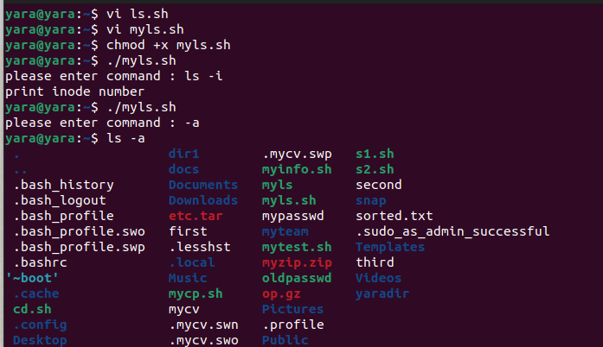

**7-**

**#!/bin/bash**

**if [ $# -eq 0 ]; then**

**echo " no argument"**

**exit 1**

**fi**

**if [ -e "$1" ]; then**

**echo "type of '$1':"**

**if [ -f "$1" ]; then**

**echo "file"**

**elif [ -d "$1" ]; then**

**echo "direcotry"**

**else**

**echo "none"**

**fi**

**else**

**echo "'$1' not here"**

**exit 1**

**fi**

**echo "persmission of '$1':"**

**if [ -r "$1" ]; then**

**echo "read :yes "**

**else**

**echo "read : no"**

**fi**

**if [ -w "$1" ]; then**

**echo "write : yes"**

**else**

**echo "write : no"**

**fi**

**if [ -x "$1" ]; then**

**echo "execute : yes"**

**else**

**echo "execure : no "**

**fi**

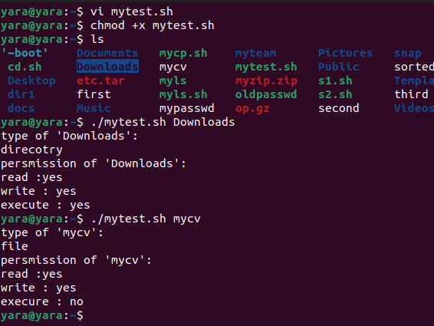

**8-**

**Vi myinfo.sh**

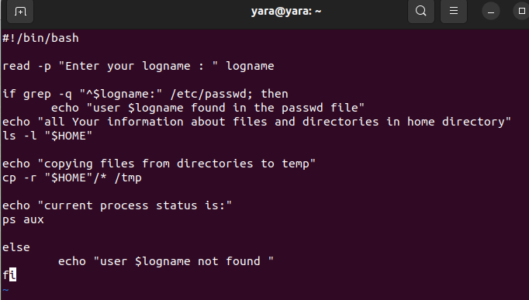

#!/bin/bash

read -p "Enter your logname : " logname

if grep -q "^$logname:" /etc/passwd; then

echo "user $logname found in the passwd file"

echo "all Your information about files and directories in home directory"

ls -l "$HOME"

echo "copying files from directories to temp"

cp -r "$HOME"/* /tmp

echo "current process status is:"

ps aux

else

echo "user $logname not found "

fi

